Zaalima Development Internship First Project Review ﻿
E-commerce Conversion Funnel DashBoard
From
Vinith. T

- Requirement Understanding
  - Identified business problem and dashboard objectives
  - Finalized key KPIs: Sessions, Orders, Conversion Rate%, Drop-off %, Campaign Performance, etc.
- Data Collection
  - Collected data from ecommerce web analytics sources
  - Exported datasets in CSV/Excel format.
- Data Import into Power BI
  - Opened Power BI Desktop
  - Used Get Data →Excel Workbook > Load.
- Data Cleaning & Transformation (Power Query Editor)
  - Removed unnecessary columns
  - Remove duplicate data, remove blank rows.
  - Next load the data set
- Data Modeling
  - Built relationships between table
  - Ensured correct relationship directions and cardinality
- Creating Measures and Calculated Fields (DAX)
  - DAX:
Total Sales = ecommers[Quantity] * ecommers[price_usd]
Profit = ecommers[Total Sales] - (ecommers[Quantity]ecommers[cost_usd])
Profit % = DIVIDE(ecommers[Profit], ecommers[Total Sales])

- Dashboard Layout Design
  - Selected report theme and colors for better readability
Add Cards visual:
  - Total Revenue
  - Total profit
  - Average Profit%
- Visualizations
- Funnel Chart
- Bar chart
- Pie chart
- Clustered Column chart
- Line chart
- Map
- Interactivity and User Experience
  - Added slicers :
Source
AGE
Category
10.Screenshot :

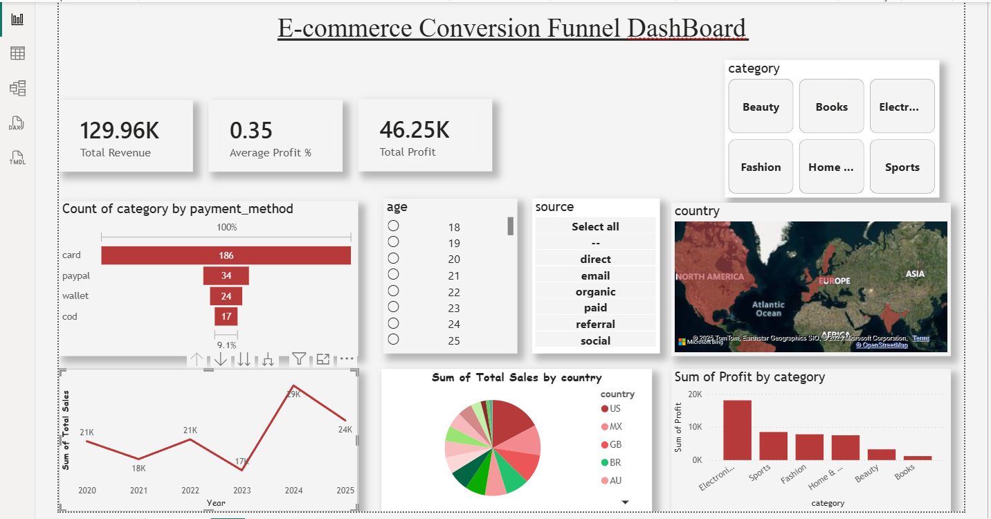

11. summary:
- This dashboard shows how users move through the online shopping funnel.
- It tracks key metrics like visits, add to cart, checkout, and purchases.
- Helps identify at which stage most users drop off.
- Shows which campaigns and devices bring better conversions.
- Supports improving user experience and boosting sales.

